Create Docker private registry in Nexus.

Installing nexus.

@ Install Prerequisites

# Install OpenJDK : Java requires to run nexus

# yum -y install java-1.8.0-openjdk

@ Installing Nexus.

# cd /opt

sudo wget <https://download.sonatype.com/nexus/3/latest-unix.tar.gz>

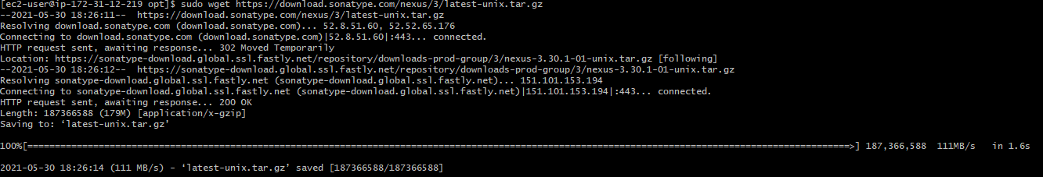

sudo tar -xf latest-unix.tar.gz



sudo mv nexus-3.30.1-01/ nexus3

@ using “chown” command change nexus and sonatype-work folders permission to user “ec2-uer”.

# sudo chown -R ec2-user:ec2-user nexus3/ sonatype-work/

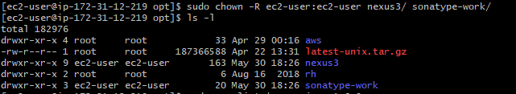

# sudo yum list | grep java-1.8.0

# sudo yum install java-1.8.0-openjdk

# java -version

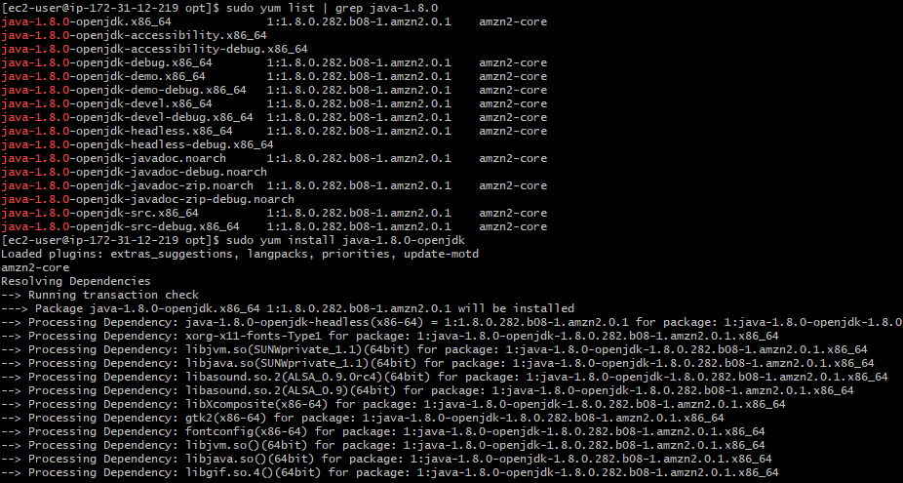

@ Browse to /opt/nexus3/bin and find nexus.rc file set run user as a specific user

Note: Nexus shouldn’t run on root user

# vim nexus.rc



@ Create soft link to operate nexus using init.d service

#sudo ln -s /opt/nexus3/bin/nexus /etc/init.d/nexus

# cd /etc/init.d/

@ Make sure nexus run if system reboot also

# sudo chkconfig --add nexus

# sudo chkconfig nexus on

@ Start the nexus service

# sudo service nexus start

# sudo service nexus status

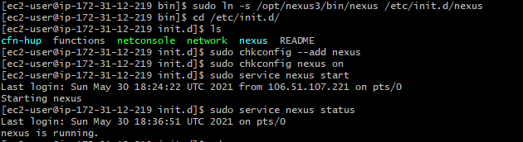

@ login nexus in browser using IP Adress:8081 port once login enter credentials username “admin” password “you can find in this path /opt/sonatype-work/nexus3/admin.password” by using cat command

cat Your admin user password is located in

# cat /opt/sonatype-work/nexus3/admin.password

@ Enable http protocol and give port to connect on that while creating Nexus repo N enable docker api version v1.

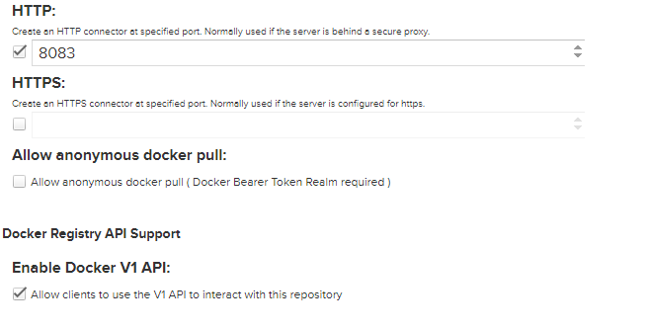

@ Setting docker with nexus repository

Older versions of Docker were called docker or docker-engine. If these are installed, uninstall them, along with associated dependencies.

$ sudo yum remove docker \

docker-client \

docker-client-latest \

docker-common \

docker-latest \

docker-latest-logrotate \

docker-logrotate \

docker-engine

Install the yum-utils package (which provides the yum-config-manager utility) and set up the **stable** repository.

$ sudo yum install -y yum-utils

$ sudo yum-config-manager \

--add-repo \

https://download.docker.com/linux/centos/docker-ce.repo

Install the latest version of Docker Engine and containerd, or go to the next step to install a specific version

sudo yum install docker-ce docker-ce-cli containerd.io

@ to start docker

sudo systemctl start docker

@ Once docker is installed create file “ /etc/docker/daemon.json” using below command

# vi /etc/docker/daemon/json

@ Place below content in file N save [ Nexus public port number or dns:nexus repo http port]

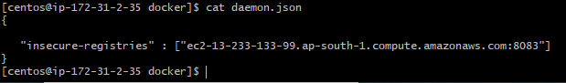

Restart docker again to apply changes.

# systemctl docker restart

@ Login to nexus repo using below command

#

sudo docker login -u admin ec2-13-233-133-99.ap-south-1.compute.amazonaws.com:8083

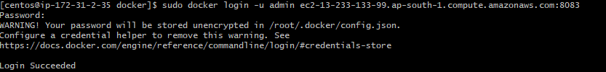

@ Now you can push the images directly to nexus repo.

sudo docker push ec2-13-233-133-99.ap-south-1.compute.amazonaws.com:8083/nexus3

